AGENDA

JUNIT 5
- What is test and why J Unit?
Unit Test: A unit test is a small piece of code that calls our code and checks whether the actual result matches the expected result.
Analogy: Before selling a cake, we taste a slice to check whether it is sweet enough. Similarly, a unit test automatically checks our code every time we change it to ensure it still works correctly.
With test you press one button and no whether everything still works, Junit 5 is the library that gives tools to write and run those checks.
Every test follows the same 3 steps
- Arrange: Set up the required data and objects.
- Act: do that thing
- Assert: Check the answer
Eg:
// Arrange: set things up
Calculator calc = new Calculator();
// Act: do the thing
int result = calc.add(2, 3);
// Assert: check the answer
assertEquals(5, result);

TYPES OF Testings:
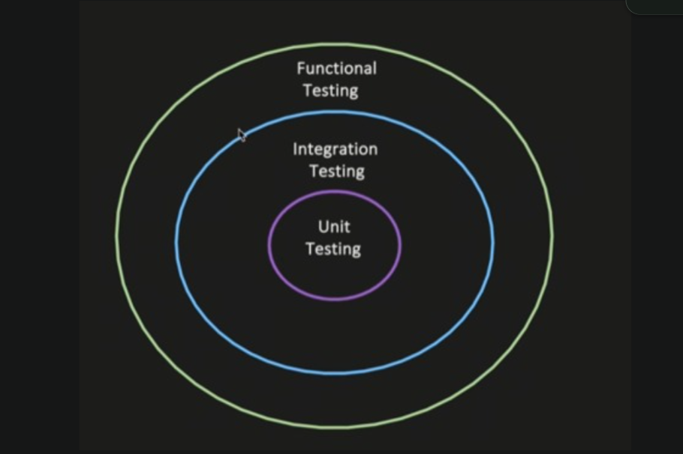

1)Unit Testing
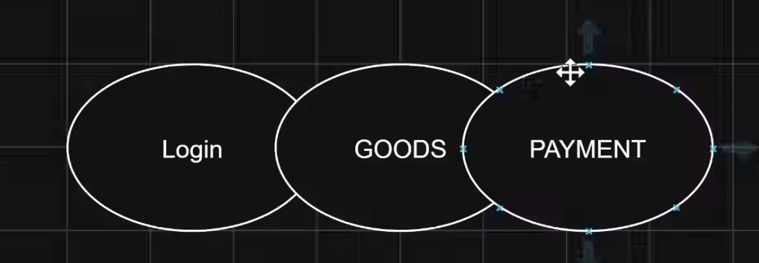
Testing of an individual unit or a method;

- Functional Testing
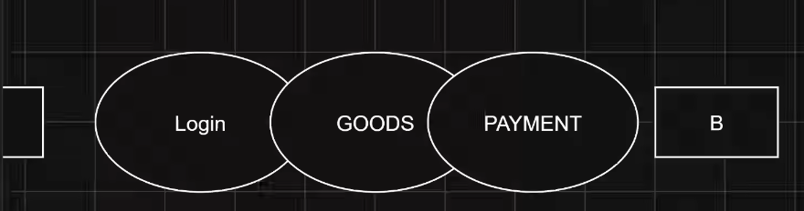

Testing of multiple modules /components to test if system behaves properly, when wired together
End to end testing of a feature or business functionality, verifying if it works as expected.

3)Integration Testing
The goal is not to test end to end user behavior, it is just a multiple modules or systems wired together, does intended behavior.
USECASE 1:
Service => Repo =>DB
Wired multiple modules of one component
- You invoke method to service layer
- Verify that dependency injection works correctly
- The flow should reached the DB Layer
- To your test And assert the data was persistence into DB
Service A => publish to Kafka
Validate that msg is successfully publish to the Kafka topic

2)What is Maven?

Maven is a project management and build tool for Java. It does three main jobs:
- Downloads libraries such as JUnit and other required .jar files.
- Compiles code into executable bytecode.
- Runs tests using a single command, such as mvn test.
Analogy: Imagine you are a chef writing a recipe (Java code). Maven is your kitchen manager, and pom.xml is your shopping list. The manager arranges the required ingredients (libraries), helps prepare the dish (builds the project), and checks whether the dish meets expectations (runs tests).
POM stands for Project Object Model. The pom.xml file contains project details, dependencies, and build configuration.
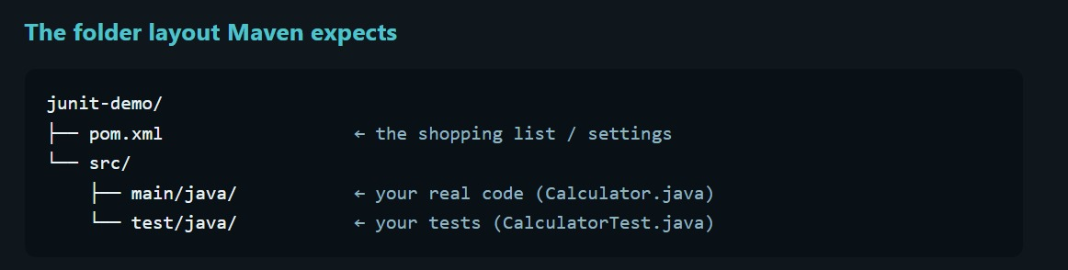
Maven Commands (Syntax)
- Check Maven version
mvn -v
Displays the installed Maven and Java versions.
- Compile the project
mvn compile
Compiles the main Java source files.
- Compile test code
mvn test-compile
Compiles the test source files.
- Run tests
mvn test
Compiles the project and runs the tests.
Remember: mvn compile compiles your main code, while mvn test runs your tests too.

3)Desgin Junit
a) Understand the problem statement: Identify the requirements and write pseudocode (step-by-step logic).
b) Write code: Implement the solution in Java.
c) Write tests: Create JUnit 5 test cases to verify the expected results.
d) Run tests: Execute mvn test to check whether the code passes or fails the tests.

3)Assersation and Annotation
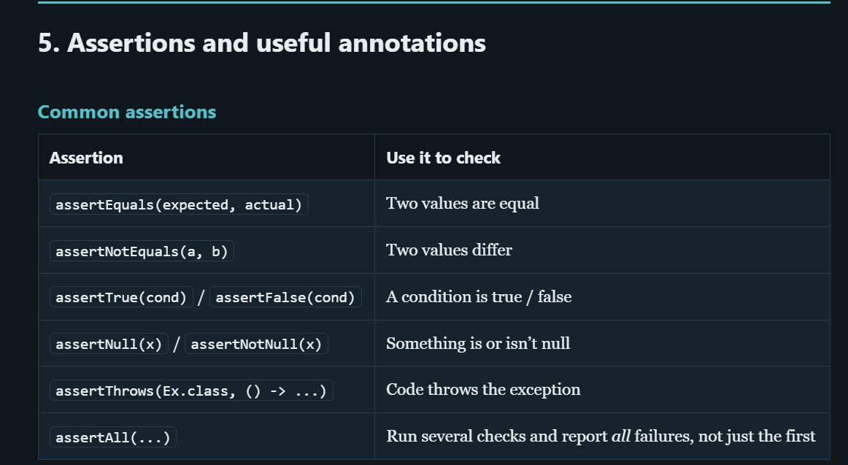

- test life cycle
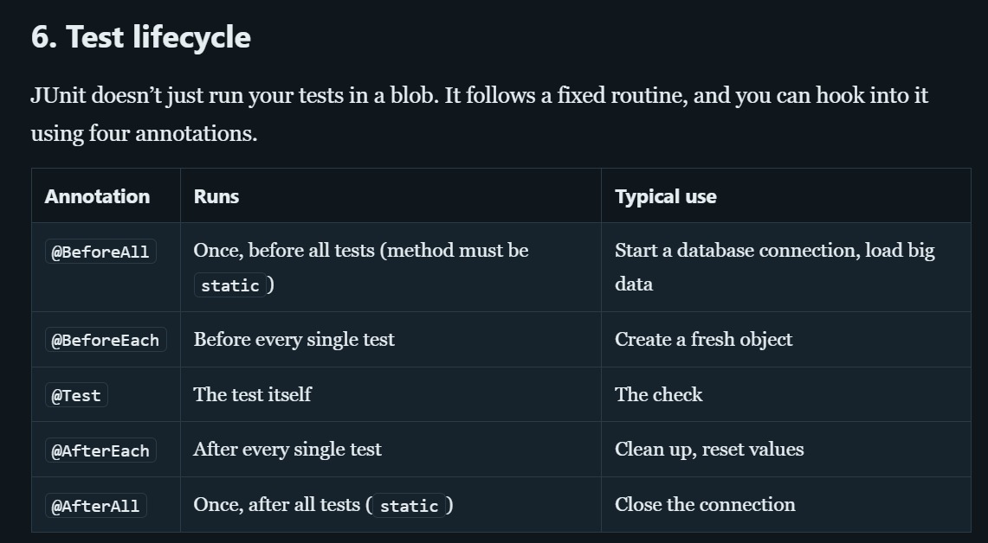

5) junit 5 architecture

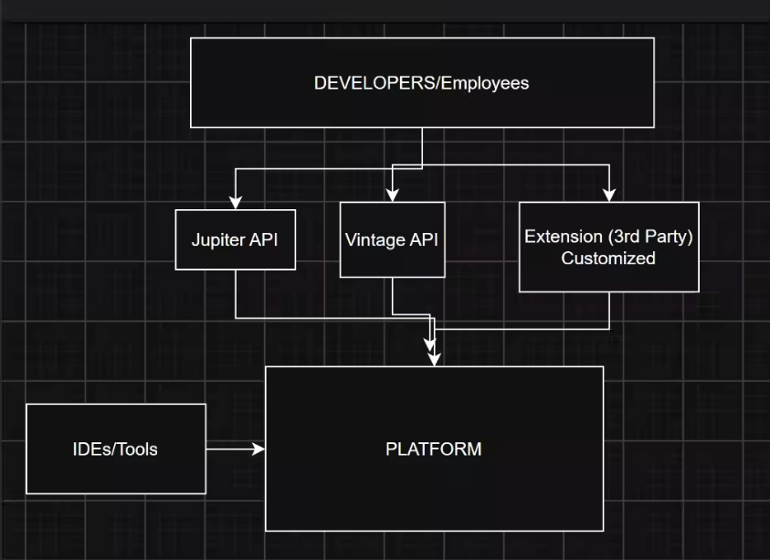

- IDE’s/ Tools
The engine room. Starts tests talks s to IDE’s Maven ,defines how test engnies plugin, it is used by Intellij, VS code and Maven surefire
It is used by the developer while writing a test

- Junit Jupiter
It is new programming model; @Test @BeforeEach, assertions. Also contains the engine that runs Jupiter tests

- Junit Vintage API
A compatibility engine that runs code Junit 3 and 4 tests on the new platform, it is used by Old projects that haven’t yet migrated.
Anology:
Analogy: A Cinema
- JUnit Platform: The cinema building and projector system that runs tests.
- JUnit Jupiter: Modern movies (JUnit 5 tests).
- JUnit Vintage: Old movies (JUnit 3 and JUnit 4 tests) that can still play on the same projector.
The platform supports both modern and older tests, so existing projects can continue working without immediately rewriting all their tests.

